**How to schedule start/stop tag in Azure Automation**

**Step1:** Go to Home-Automation Accounts->backuptest(Account-Name)->Runbook->shutdownstartbytag(Runbookname)-> Schedules

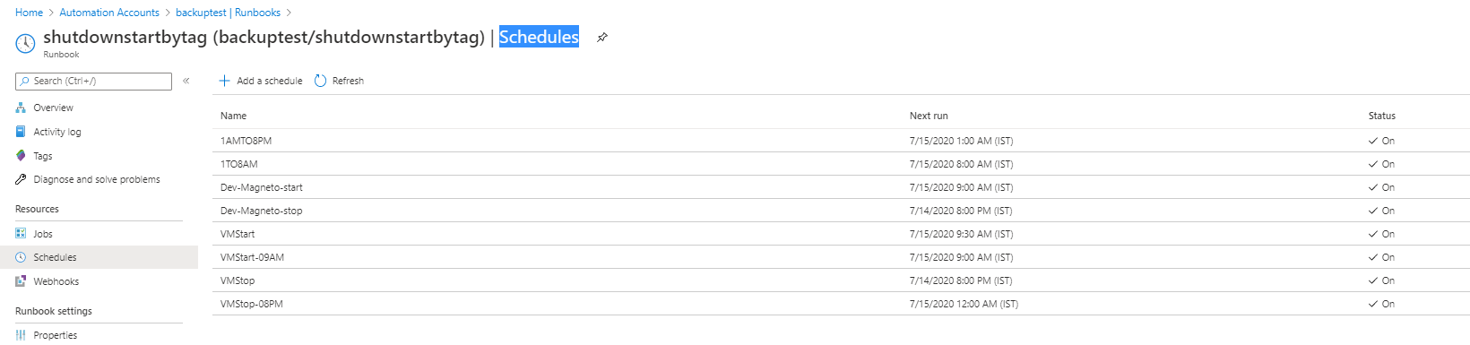

Step2: In Schedules, Select Add a schedule and create a schedule for VM start/stop.

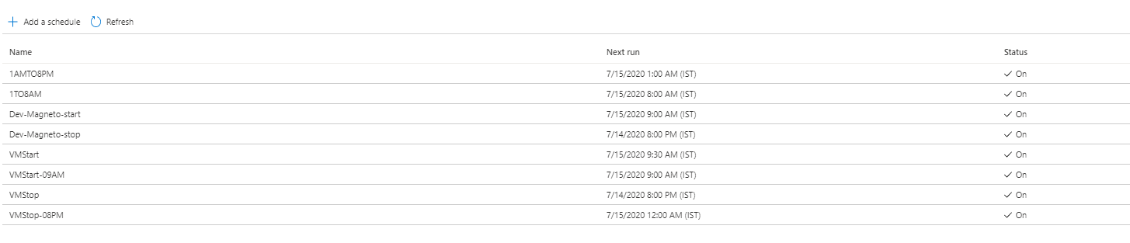

Step3: VM start tag schedule below. First Schedule creation

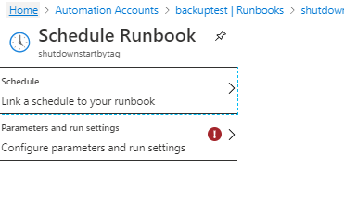

Fill all the details and select Create.

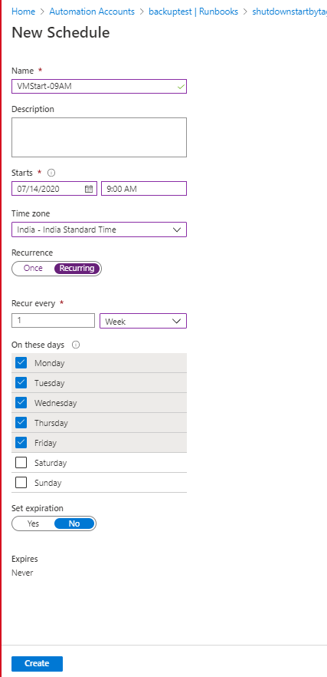

The above schedule for Weekdays we can chose different recurrence option based on the request.

Once that is completed. Select parameters and fill the details.

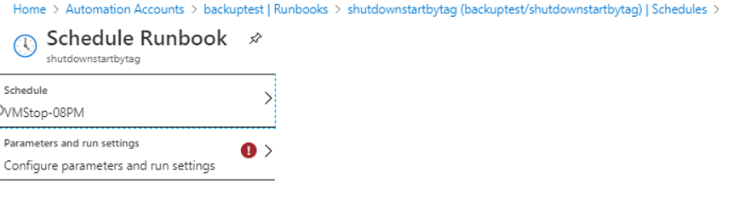

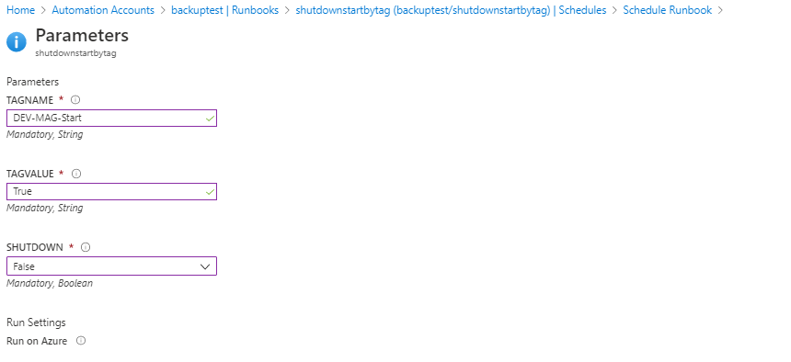

Note: For VM start tag, the Shutdown option must be False and for the VM stop Tag the shutdown option must be in True.

Step4: For VM Stop tag- Same as above except the some changes.

* Change the time
* Shutdown behaviour must be in True.

Once the schedules are created successfully. Add the Tag name and value which we have given in the parameter section in the appropriate server where we need to follow the above schedules.

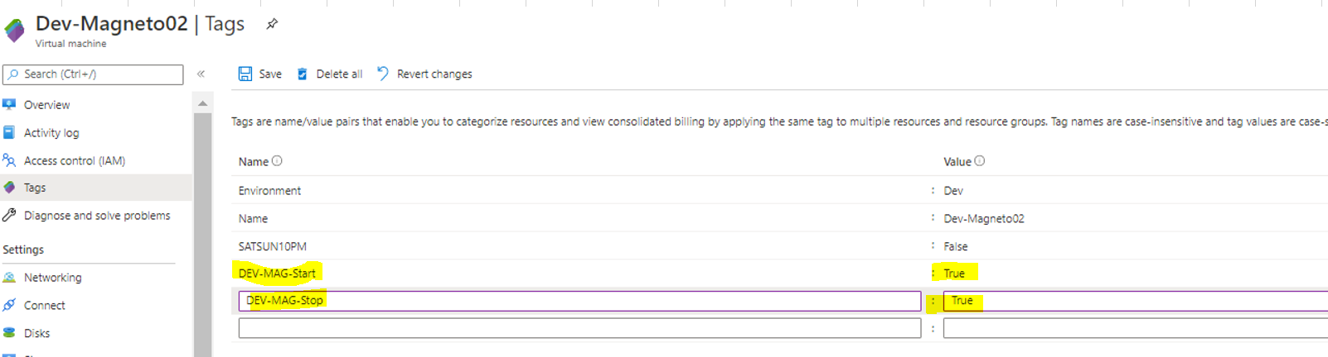

In case if you want to change the parameters of the schedule. Choose the schedule and select unlink and change the required details.

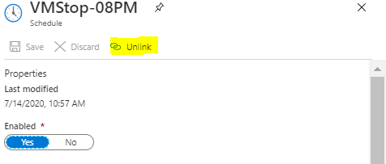

To add the schedule, Select schedule and click ADD a schedule where you can see the schedule we have unlinked.

